CDAC MUMBAI

PG-DBDA Cdac Kharghar

DATA VISUALIZATION

DAY : SATURDAY, 20TH AUGUST 2022 TIME : 2:00 PM to 4:00 PM

___________________________________________________________________________

Q1. Create a sample table in postgres/mysql with following columns (15 Marks)

Table Name : cdac_power_bi

Column

Name - varchar

Id- integer

Age- integer

Dob - date

Insert 5 dummy rows into it and then connect to superset and populate

1. Table Chart

2. Card chart showing max age

**1.Opening Mysql**

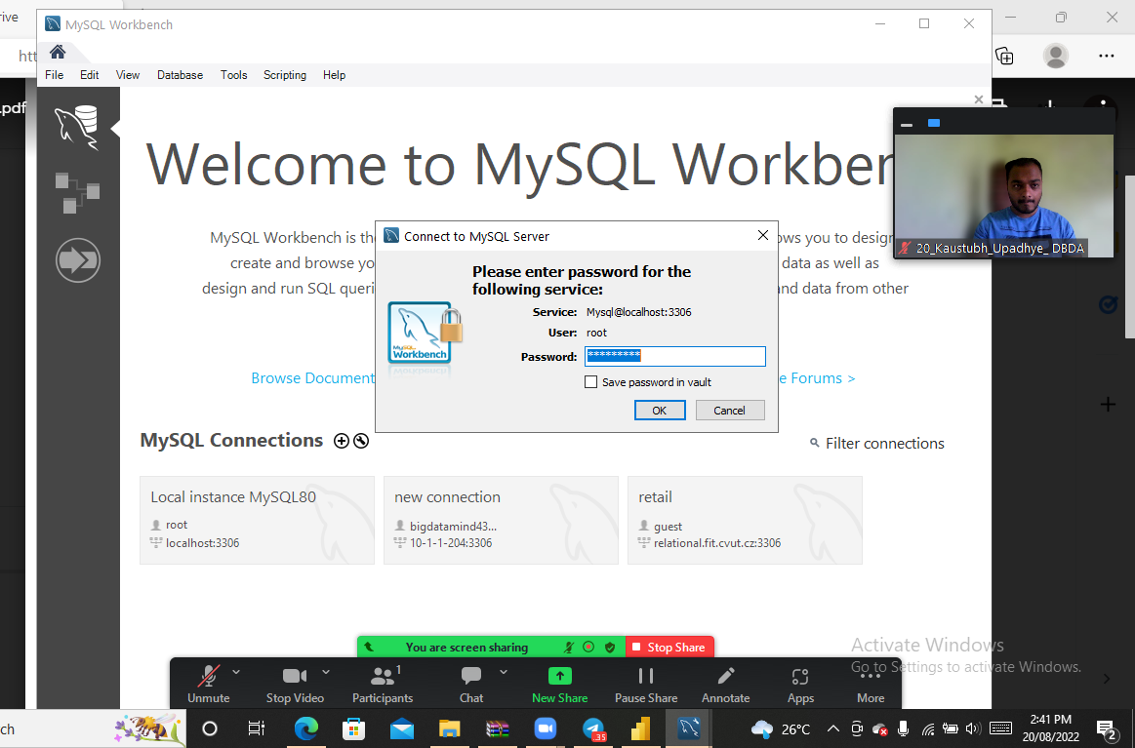

**2.Creating data and inserting data**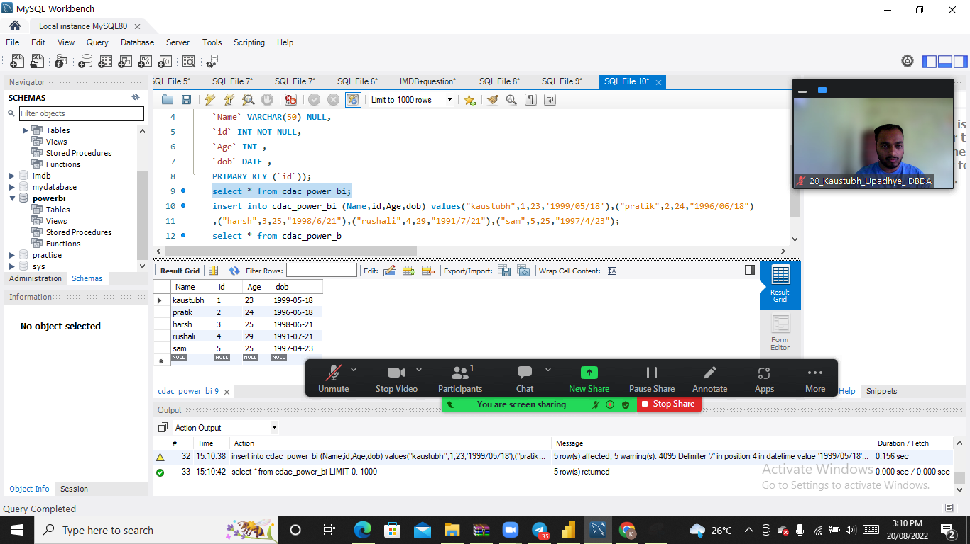

3.Opening PowerBi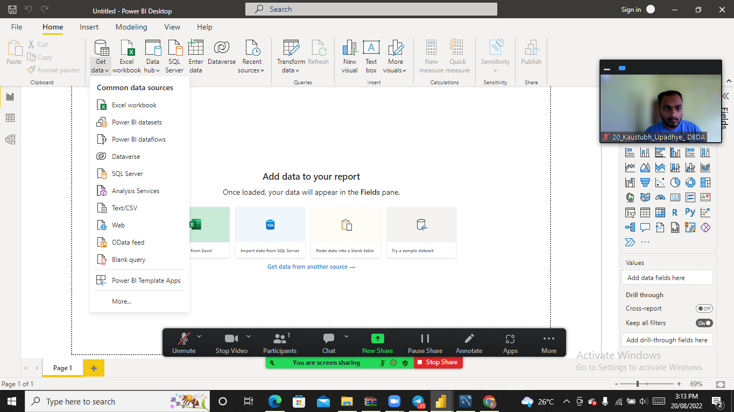

4.connect Mysql from ODBC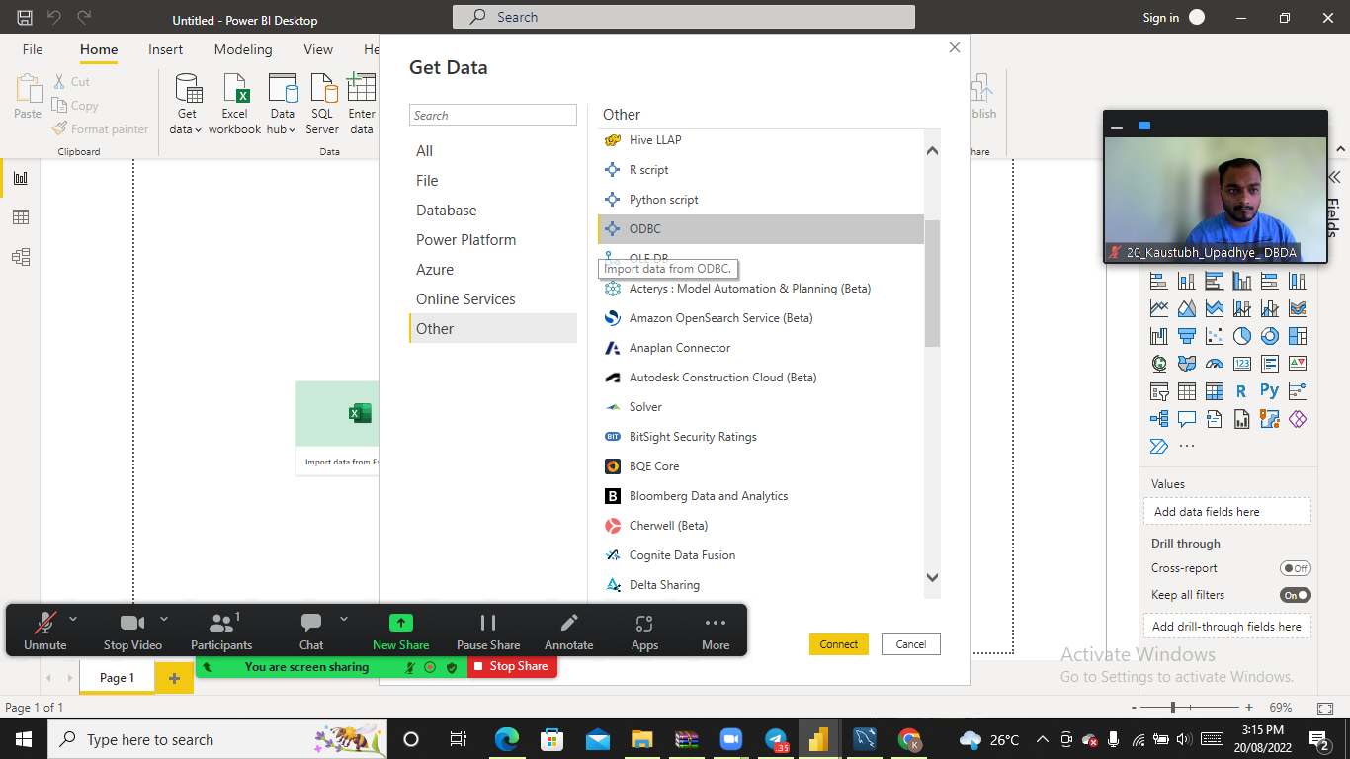

5.Entering local data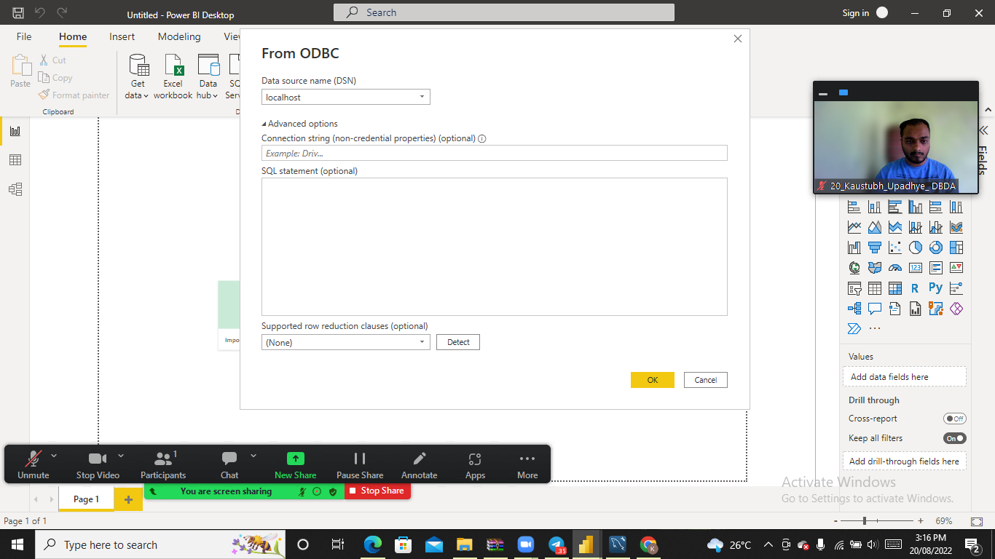

6.All the tables are fetched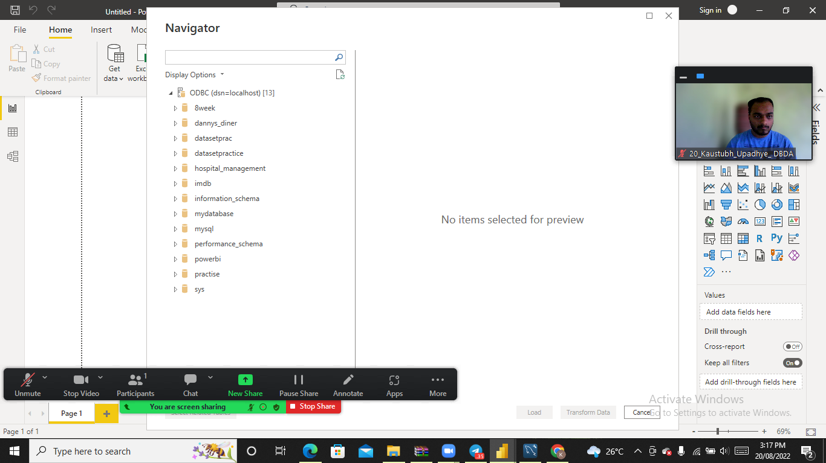

7.select table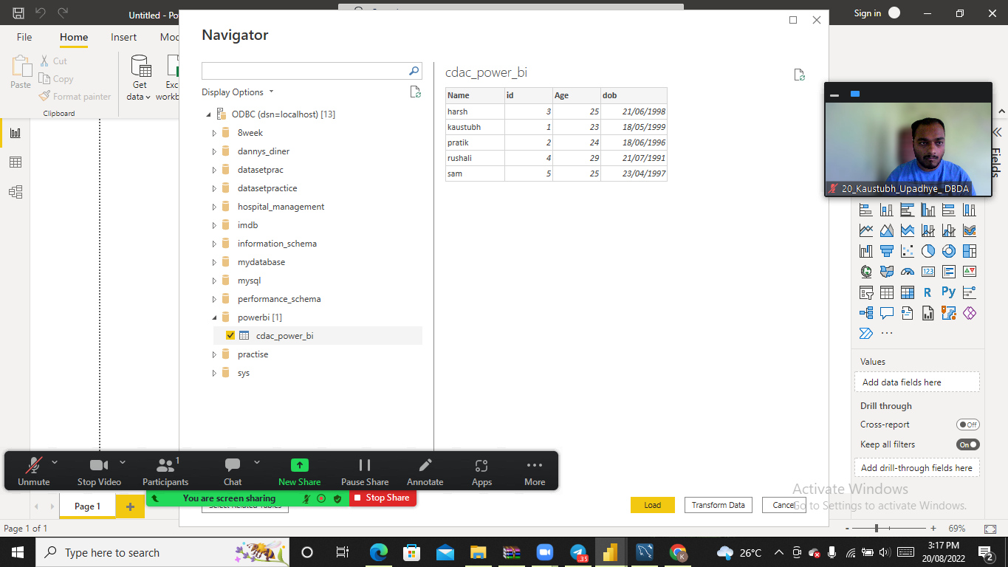

8.the data created in mysql

9.creating table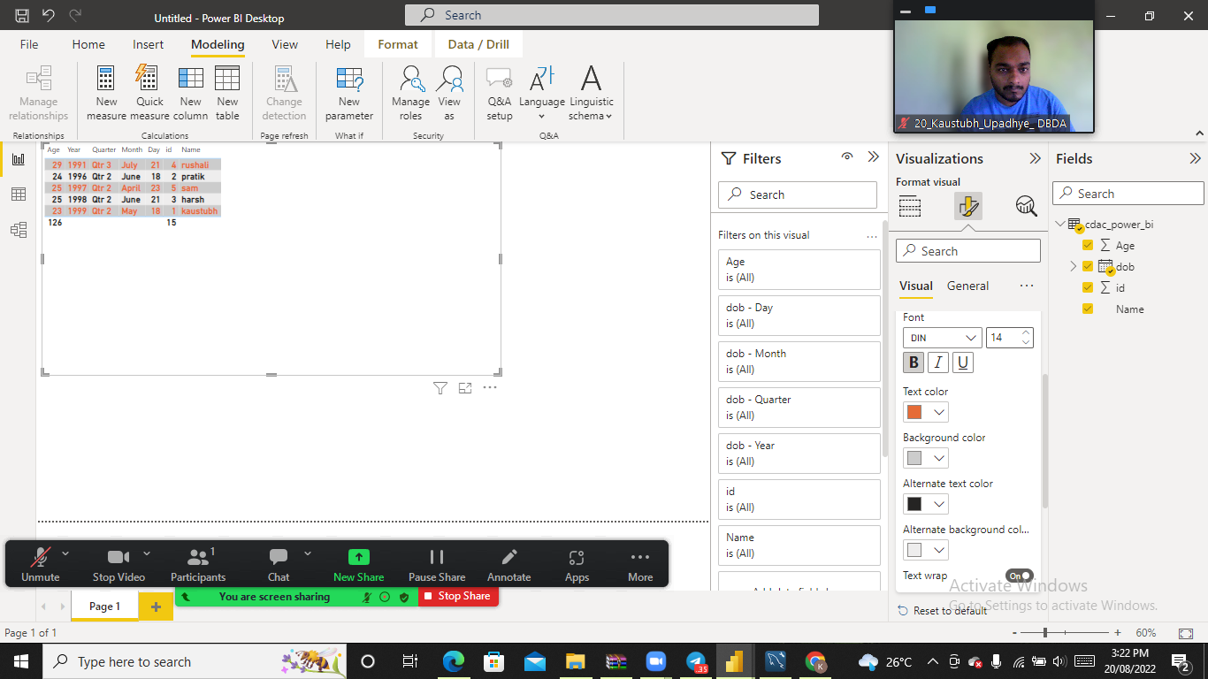

10.visulizing table

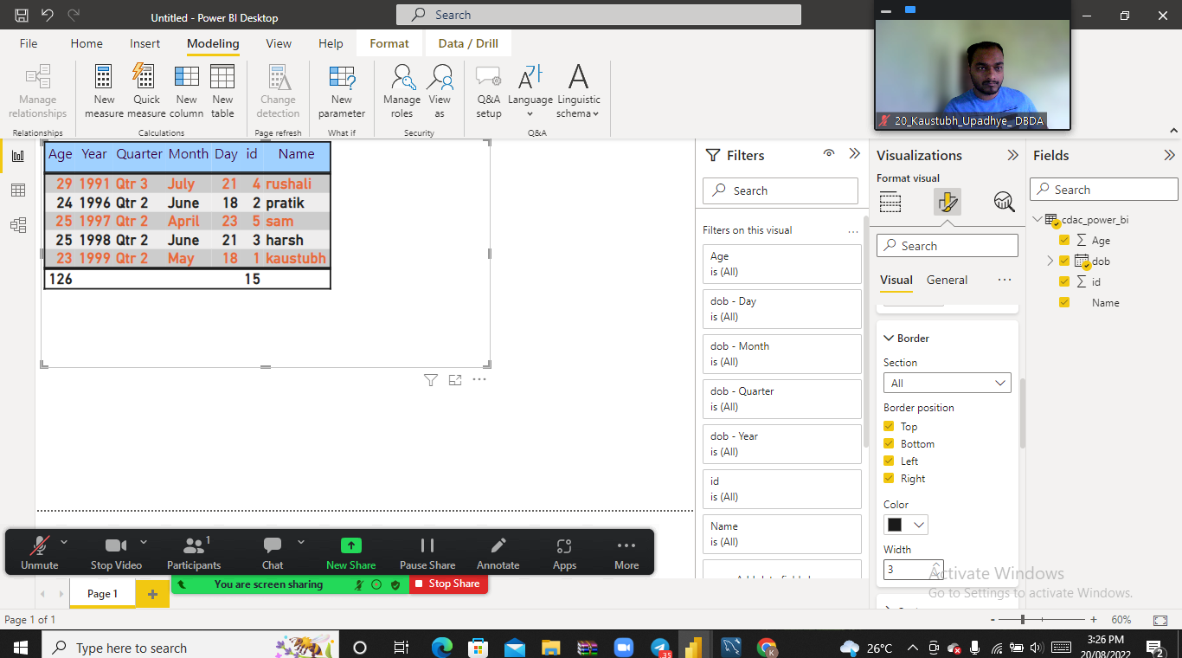

11.Card chart

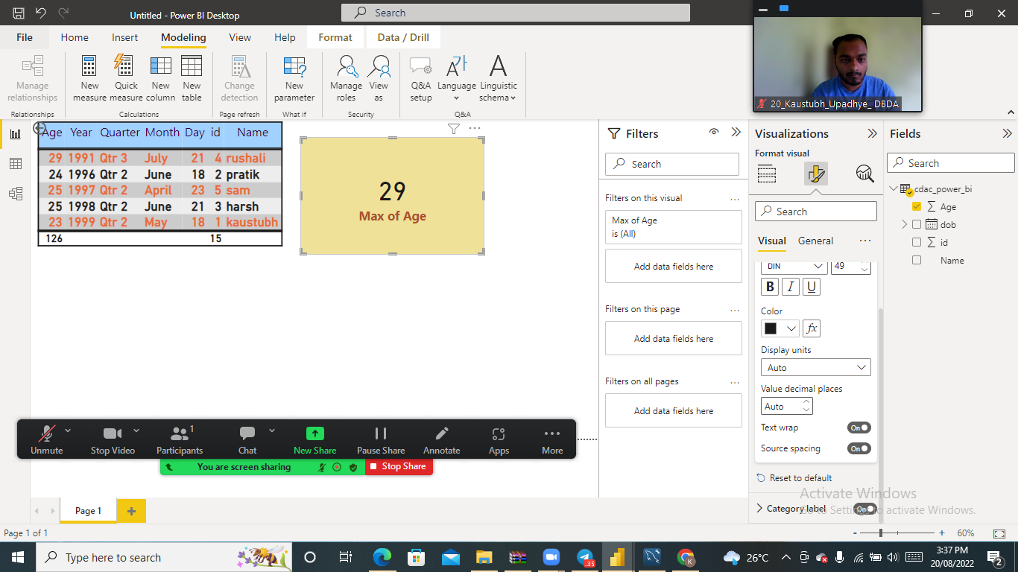

12.All the question visualized on report,All 2 charts are shown

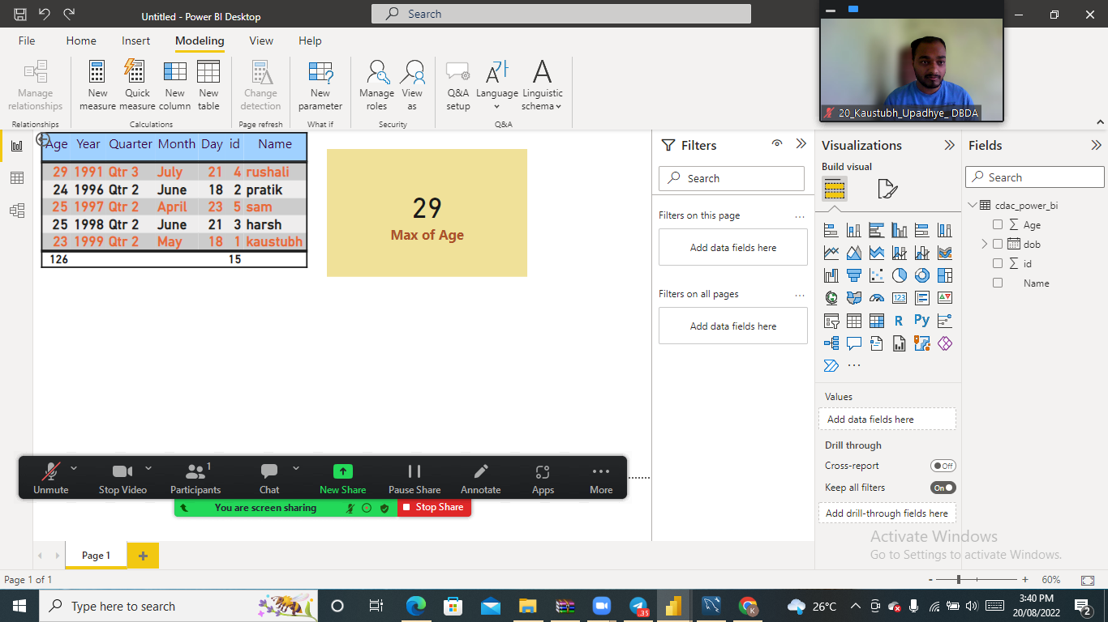

Q2.On product_table data set do the following (25 Marks)

● Create table chart with title , vendor,customer name,quantity,price,city

● Add new calculated column naming total_sales which is derived from quantity * price

● Add new measure naming max_price to get max of price column and then display every

vendor max price in table chart

● Create pie chart showing the value and percentage of quantity by vendors

● Create one more column naming total_sales_2022 which is derived from quantity *

price * 1.16

● Create clustered column chart showing both total_sales and total_sales_2022

● Create a slicer chart of price

● Calculate avg sales and show in tile ● Create gauge chart with

○ value as total_sales

○ Maximum value as max of total_sales_2022

○ Target Value as average of total_sales

1.creating table with some visualization like colouring.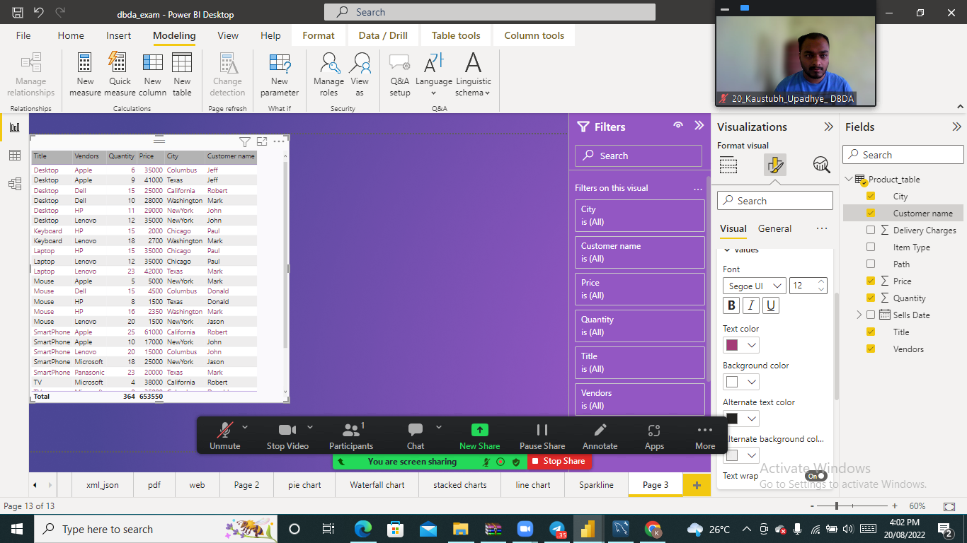

2.creating colulm with total_sales 2022 so we wrote formula for new colulmn

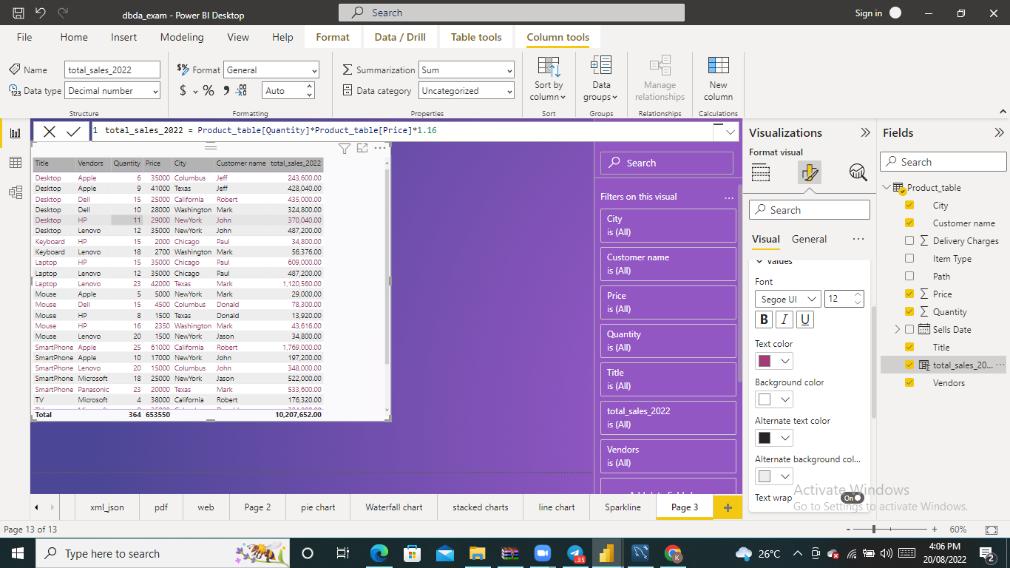

3.Now pie chart that showing the value and percentage of quantity by vendors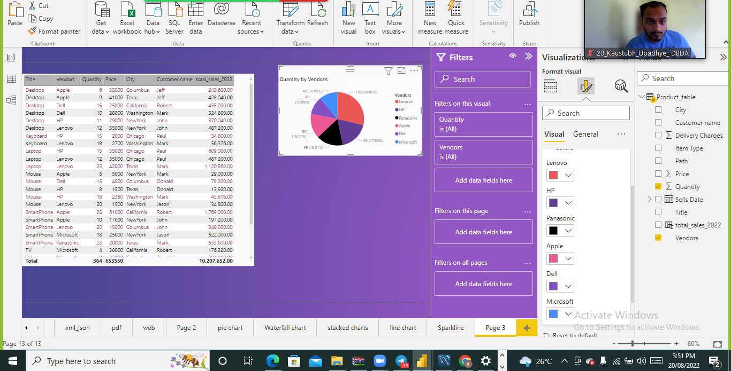

3.Create clustered column chart showing both total_sales and total_sales_2022

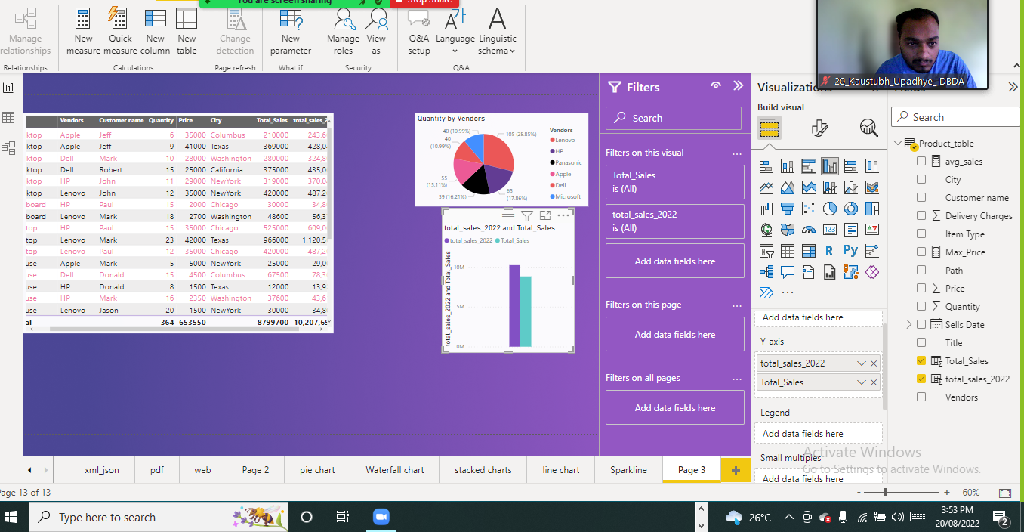

5.total_sales column

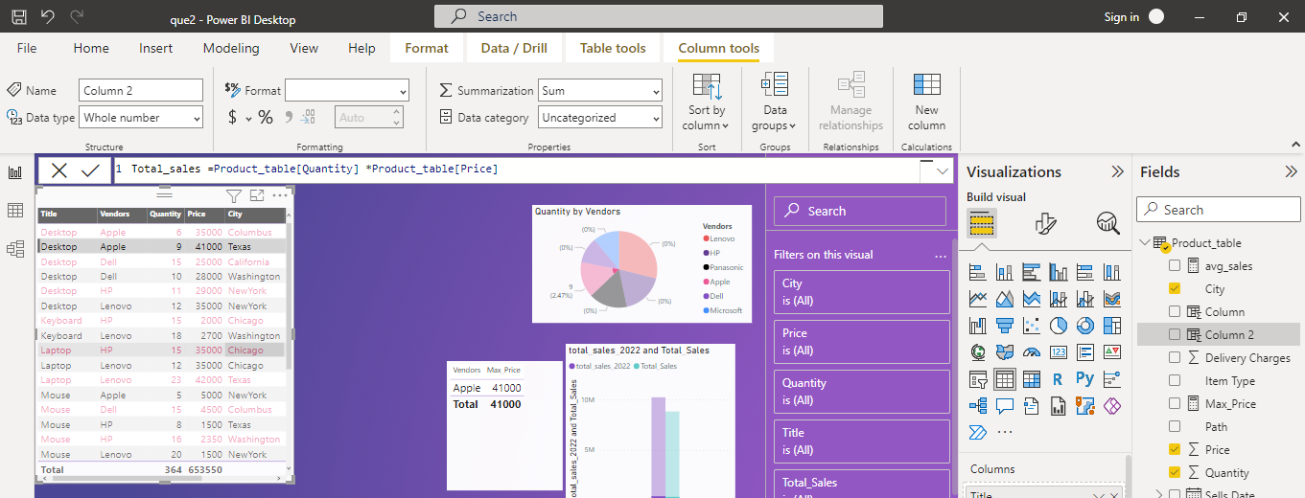

6. a slicer chart of price

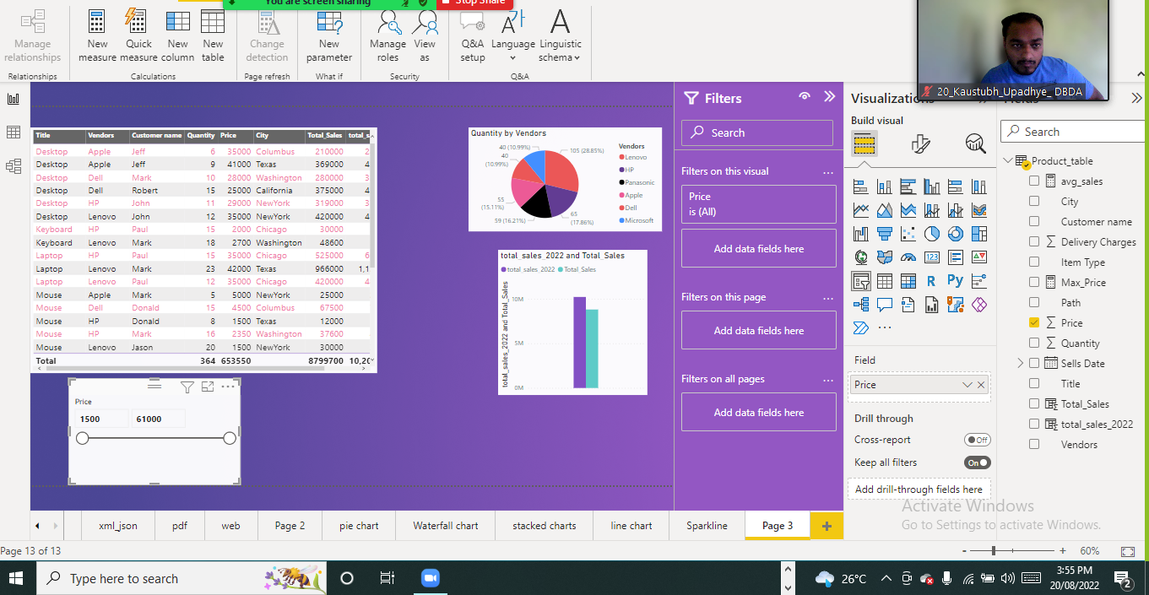

7. ● gauge chart with

○ value as total_sales

○ Maximum value as max of total_sales_2022

○ Target Value as average of total_sales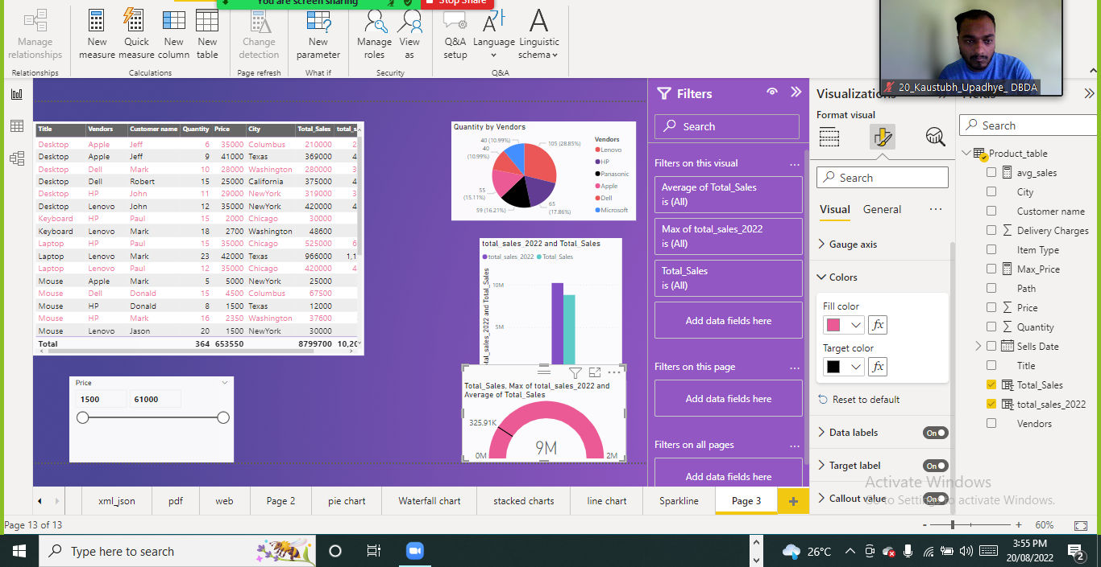

Calculating average

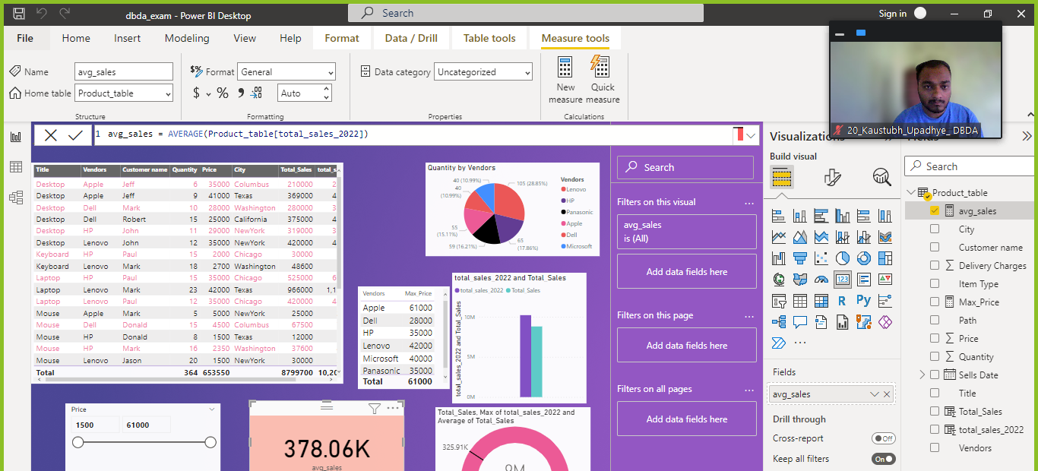

********Final Report is ready to Publish****************************

